**10 Adventures From the Last Year**

As I write this, it is May 2022. In the last 12 months, I have participated in all of the following adventures. Click on any picture to enlarge.

[caption id="attachment_291511" align="alignright" width="400"][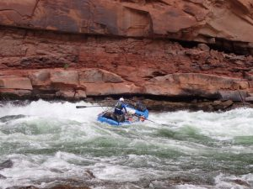](https://www.whitecoatinvestor.com/wp-content/uploads/2022/05/Grand.jpg) Trying to keep the rubber side down in the Grand Canyon[/caption]

**# 1 Grand Canyon Whitewater Rafting**

One of my retiring partners drew a coveted Grand Canyon private rafting trip and I managed to convince her to give me one of the 16 spots on the trip. To make it even better, I talked her into allowing Katie to join us for the second half of the trip. A Grand Canyon float trip is a life-changing experience for most of the people who do it and it's easy to see why after just one trip through the Big Ditch. I had only started seriously rafting a year previous to the trip, but I had already rowed whitewater on the Green, the Colorado, and the Salmon Rivers. However, the Grand Canyon is considered "Big Water"; it's quite a step up. I wasn't just going as a passenger, I was responsible to get 2000 lbs of gear and passengers safely through 250 boat-flipping rapids in my little 16 foot boat. Early in the trip we found ourselves rowing into 60 mph winds one afternoon. It took two people at the oars of each raft just to make downstream progress. We found out the next morning that a gigantic 37 foot commercial raft had gotten sideways in that wind and flipped a couple of hours in front of us and spilled all of the guides and clients into the freezing water. One of them did not survive the experience. And I was trying to get down this canyon in a boat 1/10th the size. Katie hiked into the canyon and joined us halfway down, swapping out for another rafter. By that point, I had gained a lot of valuable big water experience in the dozens of rapids upstream, but she was plunged into 3 of the biggest rapids on the river on her first day. It was exciting to say the least. I was one of the least experienced boatmen on the trip, but I was the most experienced canyoneer. So I was in charge of some of the diversionary trips we took from the river, leading our group of newbie canyoneers through slot canyons leading down to the river. A good time was had by all and after 23 days and 277 river miles, we reached the end and parted ways. Spectacular does not begin to describe the trip.

[caption id="attachment_291512" align="alignright" width="300"][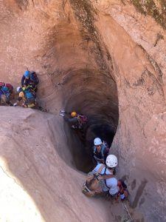](https://www.whitecoatinvestor.com/wp-content/uploads/2022/05/SlotJPG.jpg) Working a little pothole problem[/caption]

**# 2 Southern Utah Exploration**

Shortly after returning from Northern Arizona, I headed back to Southern Utah to do some exploring. In Southern Utah, exploring usually means canyoneering--the descent of slot canyons by hiking, climbing, rappelling, swimming, and a lot of teamwork. If you've never been in a real slot canyon, they're a little hard to imagine, but I typically spend a week with friends twice a year exploring these seldom-trod slots and 2021 was no exception. Whether it's "stemming" between canyon walls 50 feet off the ground, escaping 35 foot deep potholes, or rappelling bags off of water or tarps covered in sand, it's always an adventure.

**# 3 Taking Youth Camping**

One of my lesser known skills is the ability to take youth into the wilderness and bring them back alive. We have three teenagers now and our church has a separate "high-adventure" camp for young men and for young women each year. This year I was in charge of the boy's camp and Katie was in the charge of the girls camp. I went along to lend some technical expertise, so that was two weeks in the wilderness with a bunch of kids that ate up much of June.

[caption id="attachment_291513" align="alignleft" width="400"][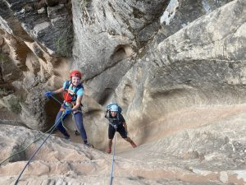](https://www.whitecoatinvestor.com/wp-content/uploads/2022/05/ZionJPG.jpg) Sometimes canyons go vertical[/caption]

Both groups opted to go to Southern Utah, although they did somewhat dissimilar trips.

The boys went to Lake Powell, doing hikes from the water and learning watersports. The girls went to Zion National Park and were introduced to the wonderful world of canyoneering. While these sorts of trips are pretty low-key by my standards, they are the most adventurous things that most of these kids have ever done,. My favorite quote? "I didn't know all they were going to have to drink was luke-warm water!" (This was 4 days out on a camping trip at 90 degrees; not sure what the kid was expecting, a slurpee machine?)

[caption id="attachment_291514" align="alignright" width="300"][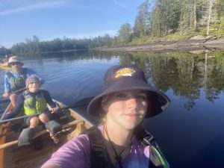](https://www.whitecoatinvestor.com/wp-content/uploads/2022/05/Boundary-Waters-Adventure.jpg) Those cute kids would never hit each other with a paddle, would they?[/caption]

**# 4 Family Canoe Adventure in the Boundary Waters**

Have you heard of mandatory fun? My kids have. And 90% of it is really fun. But in order to have that fun, there always has to be a at least a little bit of hard work, misery, and suffering. Such was the case in this July week long trip to the Boundary Waters of Northern Minnesota. The mosquitoes actually weren't too bad, at least to this Alaska boy's standards. The kids did really great, except for that one moment when there were two of them standing in the front of my canoe in the middle of the lake swinging their paddles at each other like lightsabers.

**# 5 Multi-Family Float Trip**

[caption id="attachment_291515" align="alignleft" width="225"][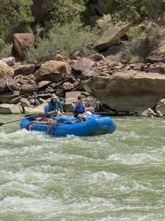](https://www.whitecoatinvestor.com/wp-content/uploads/2022/05/Desolation-Canyon-Adventure.jpg) Katie and Maren facing down a mighty Class II Rapid[/caption]

Next up was another family trip later in July. Desolation and Gray canyons on the Green River in Eastern Utah is a week-long wilderness rafting experience. While the rapids are hardly Grand Canyon-esque, they still have to be respected. However, this trip with 5 families and a plethora of kids was mostly just good, clean fun. Good meals and good friends in an incredibly beautiful place are hard to beat. Yes, it requires you to leave your bed, shower, and ethernet connection for a few days, but it's worth it.

[caption id="attachment_291516" align="alignright" width="300"][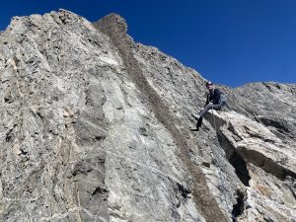](https://www.whitecoatinvestor.com/wp-content/uploads/2022/05/Drizzlepus.jpg) Katie on the summit of Drizzlepus with Mt. Moran looming above[/caption]

**# 6 Mt. Moran Climb**

I've been wanting to get back on Mt. Moran since backing off it in a rainstorm decades ago in medical school. This time, Katie came with me. Two friends, Katie, and I headed up to the Tetons. Now lots of people "do the Tetons" every summer, but we're not really content to remain at the bottom of these peaks rising 5-7,000 feet above the floor of Jackson Hole. The ascent of Mt. Moran, however, involves canoes. First you cross two lakes and stash your canoes. Then you hike up what does not deserve to be called a trail for 3,000 feet with not only your camping gear but your climbing on your back. You pitch a tent and build rock walls around it to protect from the wind. You chase a black bear out of your camp.

[caption id="attachment_291517" align="alignleft" width="300"][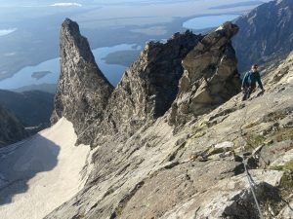](https://www.whitecoatinvestor.com/wp-content/uploads/2022/05/Moran.jpg) Katie high on the CMC face of Mt. Moran, Drizzlepus is the least impressive of the three peaks behind her.[/caption]

The next morning, you awaken long before first light (or first warmth) and begin scrambling upward trying to find the easiest way through cliff bands. You climb and climb and climb only to reach the summit of Drizzlepus, a minor peak whose summit represents the onset of the real technical difficulties and exposure. After either downclimbing or rappeling off Drizzlepus, climbers next must ascend a 1,000 foot tall wall of stone to the top of Mt. Moran before scrambling back down and reascending Drizzlepus. The climbing is actually not that hard. Doing it 2,000 feet above a glacier with open crevasses does give one pause at times however.

[caption id="attachment_291519" align="alignright" width="225"][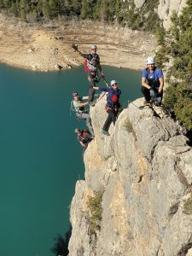](https://www.whitecoatinvestor.com/wp-content/uploads/2022/05/Via-Ferrata.jpg) This was actually the dumbest Via Ferrata we did, but it was pretty photogenic for a 5 minute climb[/caption]

**# 7 Via Ferratas in Catalonia**

We'll skip over another family trip to Lake Powell and one to Mt. Rushmore and get to our first international trip since the pandemic began. This was a couples trip to Northeastern Spain in November. While we were going to spend some time seeing tourist attractions and a lot of time eating scrumptious food, the real purpose of the trip was to do some via ferratas, aka the iron way. Think of easy, but very exposed self-belayed rock climbing with the addition of ladders, suspension bridges, trapeze bar, and even a fire pole. It actually turned out not to be that easy at all at times.

**# 8 Pandemic International Travel With Children**

[caption id="attachment_291520" align="alignleft" width="225"][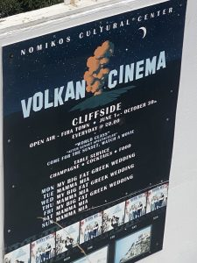](https://www.whitecoatinvestor.com/wp-content/uploads/2022/05/Greek-Culture.jpg) I kind of expected more from Greek Culture[/caption]

The Spain trip went so well we decided to try going back to Europe the next month with our kids. Greece was the selected destination. It turns out that Greece in December during a pandemic is not that crowded. We had the Acropolis to ourselves one cold morning. Of course, once we flew out to the Greek Islands we discovered why December is the off season. We did go in the water, but we didn't stay in long. Experiencing a foreign culture is always an adventure. Doing it with both a 6 year old and teenagers is a bit more hard-core. The highlight? A little place called Meteora.

[caption id="attachment_291521" align="alignright" width="300"][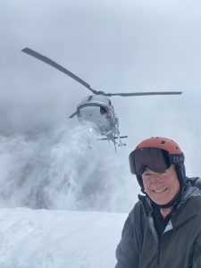](https://www.whitecoatinvestor.com/wp-content/uploads/2022/05/Heli-skiing.jpg) The Uber is here![/caption]

**# 9 Heli-Skiing British Columbia**

We'll skip over a jeeping and mountain biking trip to Moab and get to the good stuff. Some people have trouble spending their money in retirement. Most of them have never experienced the joys of heli-skiing. Imagine lifting off from the parking lot of your hotel after a delicious breakfast and flying between the most majestic peaks of the Canadian Rockies. You are then dropped off on top of a mountain that is covered with thigh deep powder without any ski tracks on it at all. After skiing to the bottom, whooping with joy the entire way, you crouch down and a helicopter lands with its skid not 2 feet away from your nose. You climb in and are whisked to the top of another mountain, again covered with thigh deep powder and no human tracks. After 4 or 5 of these, you stop halfway down a run on a glacier with a 100 mile view and are delivered hot lunch by helicopter. A few more runs and you are dropped back in the hotel parking lot. How much would that experience be worth to you? Especially knowing that a ski trip to a crowded, tracked out slope in Park City or Vail might be costing you $1,000 a day in flights, hotels, meals, rentals, and lift tickets? Guess what? Heli-skiing costs less than you would be willing to pay.

**# 10 Costa Rica Canyoneering**

[caption id="attachment_291522" align="alignleft" width="300"][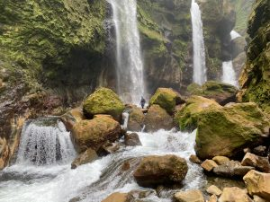](https://www.whitecoatinvestor.com/wp-content/uploads/2022/05/6-Waterfalls.jpg) Kind of a lot of waterfalls in this picture[/caption]

When your brother in law calls you up and asks if you want to go to Costa Rica in a couple of weeks to explore a few semi-legal canyons with a dope-smoking local, what do you say? I say yes. I was glad I did. I had canyons in Southern Utah saw little traffic. Some of these had just been done for the first time the previous year.

[caption id="attachment_291523" align="alignright" width="225"][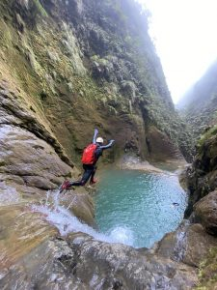](https://www.whitecoatinvestor.com/wp-content/uploads/2022/05/Jumping.jpg) Sometimes rappelling takes too long[/caption]

Colorado Plateau canyons tend to be dry. Costa Rican canyons have rivers running down them all the time. That means there is a lot more jumping and sliding involved than I was used to. But man, the place was absolutely stunning! Hard to pick a single picture to represent it, so here's two!

**# 11 Roatan SCUBA Diving**

Why stop at 10? Dial it up to 11! We started a new tradition this year by taking our graduating high school senior anywhere in the world she wanted to go to do whatever she wanted to do. She chose SCUBA diving in Roatan. I thought it was fine choice. She got PADI certified and off we went.

Roatan is one of the Bay Islands off of Honduras. They speak two dialects of English there and even a little Spanish. But the island is most famous for being ringed by one of the most beautiful reefs in the world. Most were only a 5 minute boat ride from the dock at our AirBNB too. Nothing like spending your surface intervals arguing with whole life insurance agents and Bitcoin Bros. The scenery was obviously stunning and it was great to really give her the chance to feel like an only child for a week.